MQTT NodeJS

<http://otit.fi/~scarveli/mqtt/RDVelhoDevChallenge.pdf>

https://nodejs.org/en/

<https://www.npmjs.com/package/mqtt>

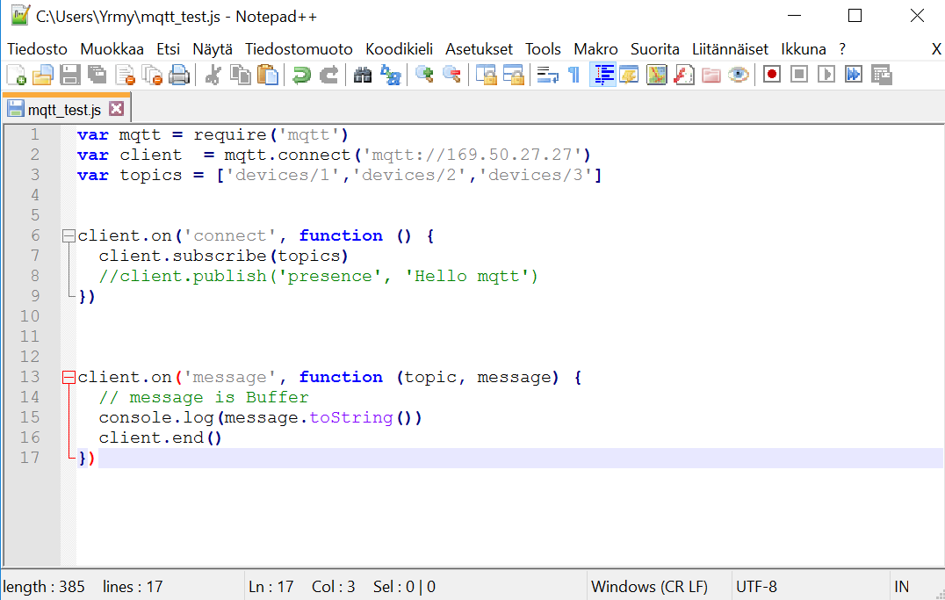

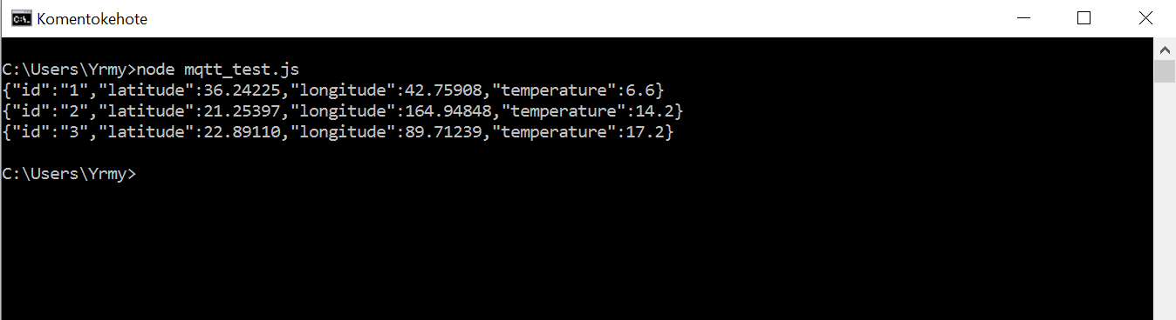

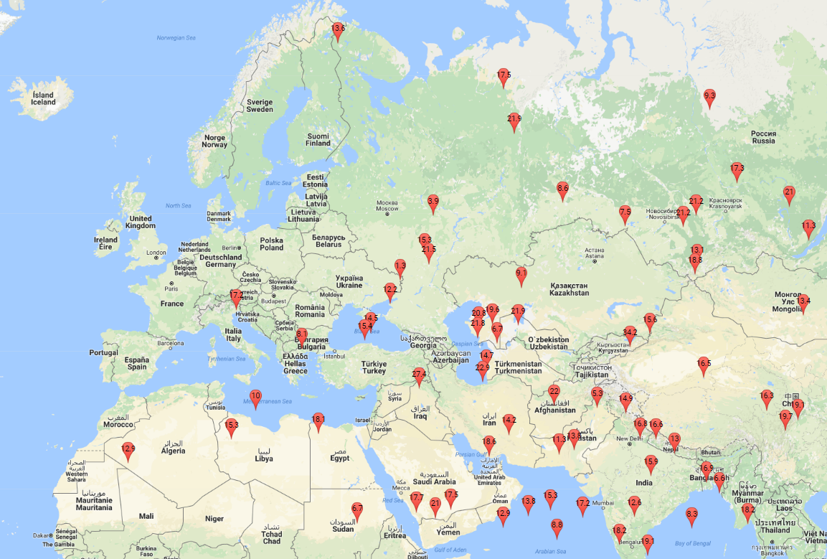

https://developers.google.com/maps/documentation/javascript/